ShopEZ – E-Commerce Application
1. Introduction
Project Title
ShopEZ – E-Commerce Application

Team Members : self project
2. Project Overview
Purpose
ShopEZ is a modern e-commerce web application that allows users to browse products, add items to their cart, manage wishlists, and place orders through a user-friendly interface. The project aims to provide a seamless online shopping experience while demonstrating full-stack development using the MERN stack.
Features
- User Registration and Login
- Product Listing and Search
- Product Details Page
- Shopping Cart Management
- Wishlist Functionality
- Discount and Offer Display
- Secure Authentication
- Responsive User Interface
- Order Placement and Checkout
- MongoDB Database Integration

4. Setup Instructions
Prerequisites
- Node.js
- npm
- MongoDB Atlas Account
- Visual Studio Code
- Git
Installation
Clone Repository
git clone https://github.com/yourusername/shopez.git
Install Frontend Dependencies
cd client
npm install
Install Backend Dependencies
cd server
npm install
Configure Environment Variables
Create a .env file:
PORT=5000
MONGO_URI=your_mongodb_connection_string
JWT_SECRET=your_secret_key

5. Folder Structure
Client (React)
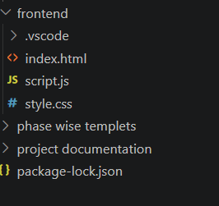
Server (Node.js)
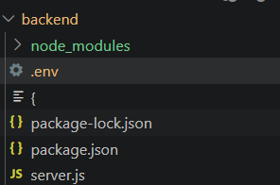
6. Running the Application
Start Backend
cd server
npm start
Backend runs on:
http://localhost:5000
Start Frontend
cd client
npm start
Frontend runs on:
http://localhost:3000

7. API Documentation
User Registration
POST
/api/users/register
User Login
POST
/api/users/login
Get Products
GET
/api/products
Add Product to Cart
POST
/api/cart/add
Create Order
POST
/api/orders

8. Authentication
Authentication is implemented using JSON Web Tokens (JWT).
Process
- User logs in.
- Server validates credentials.
- JWT token is generated.
- Token is sent to the client.
Benefits:
- Secure Authentication
- Protected API Endpoints
- User Session Management
9. User Interface
Product Listing Page:

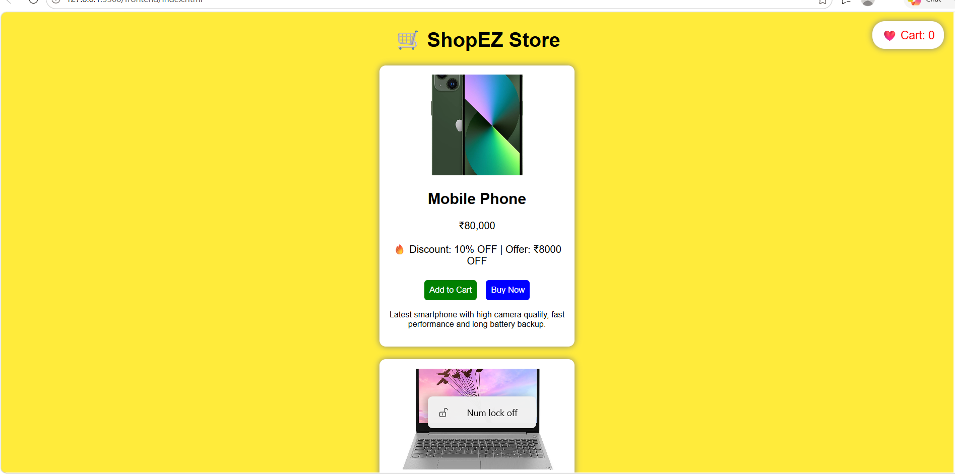

10. Testing
Testing Strategy
- Unit Testing
- API Testing
- UI Testing
- Integration Testing
Tools Used
- Postman
- Browser Developer Tools
- Manual Testing

11. Screenshots or Demo

Screenshots

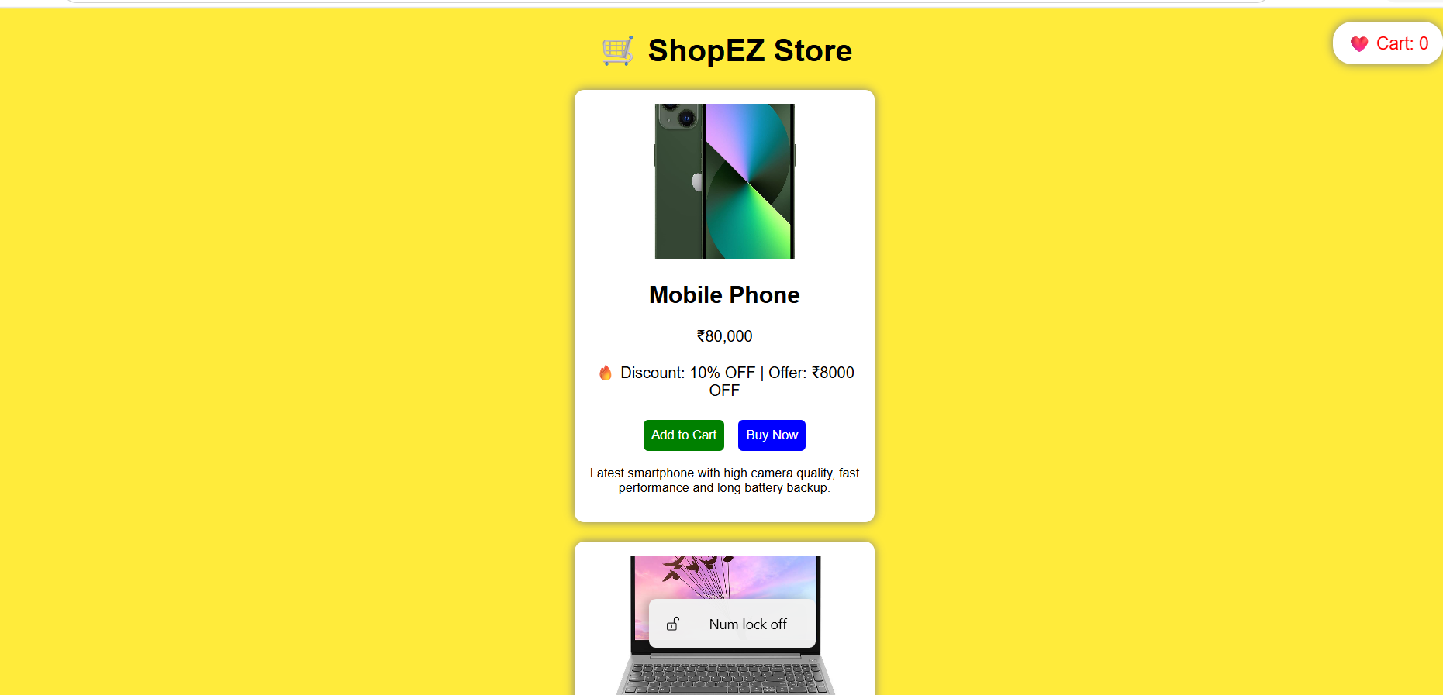
GitHub Repository

https://github.com/24eg112a37-cyber/VIP-C2-E-commerce-Application

12. Known Issues
- Payment Gateway Integration Not Implemented
- Wishlist Data Not Persisted Across Sessions
- Limited Product Filtering Options
13. Future Enhancements
- Online Payment Integration
- Product Reviews and Ratings
- Advanced Search Filters
- Order Tracking System
- Admin Dashboard
- Email Notifications
- AI-Based Product Recommendations
- Multi-language Support

Conclusion
ShopEZ demonstrates a complete MERN stack e-commerce application with modern web technologies. The project successfully integrates React.js, Node.js, Express.js, and MongoDB to deliver a scalable and user-friendly online shopping platform.

